**Lab: Explore and Extend a Classic Excel Dashboard**

**Exercise 2: Create a Pivot Table**

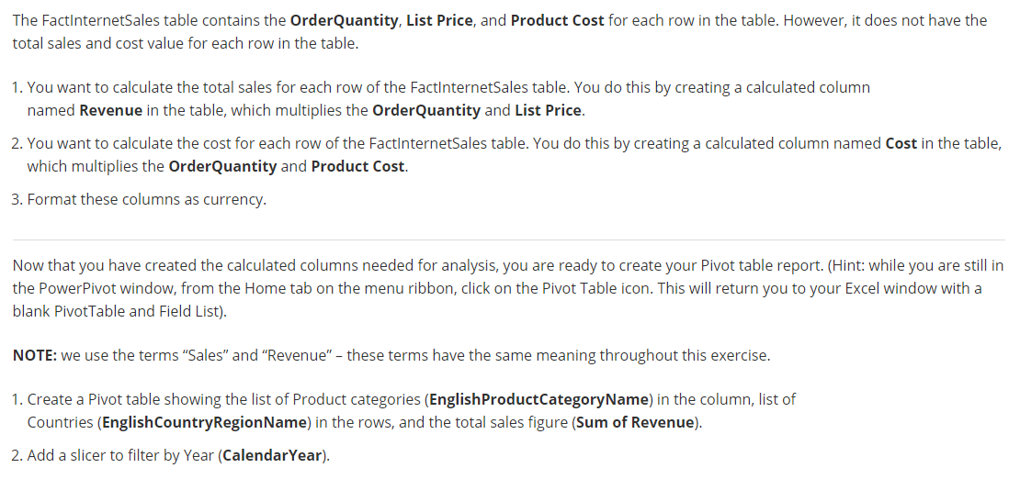

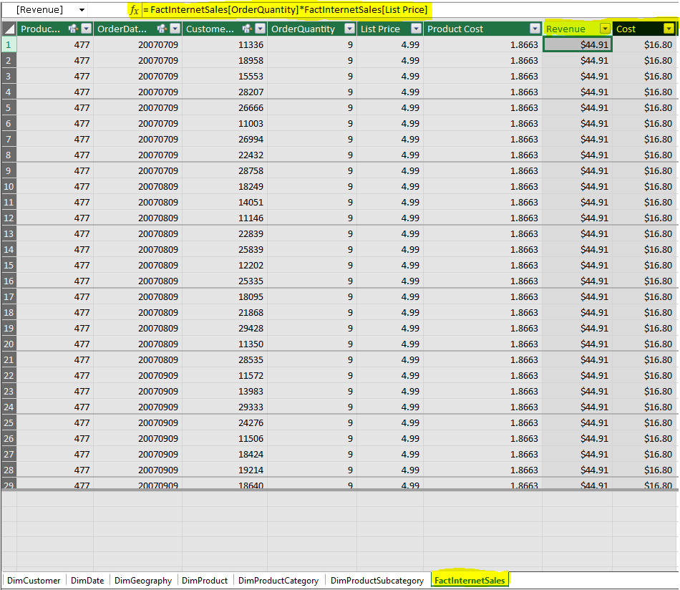



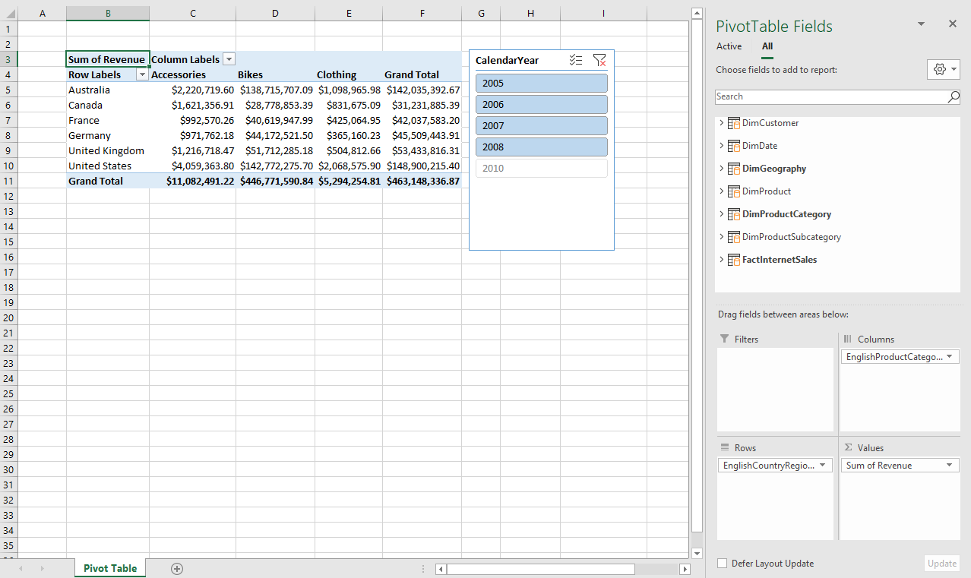

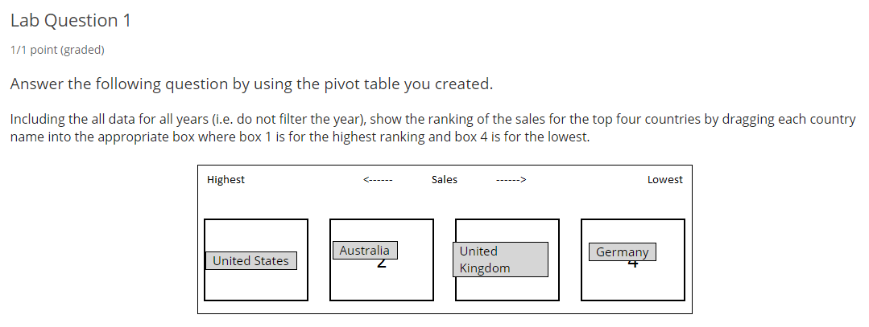

As per below sorted table,

Ans will be: US => Australia => UK => Germany

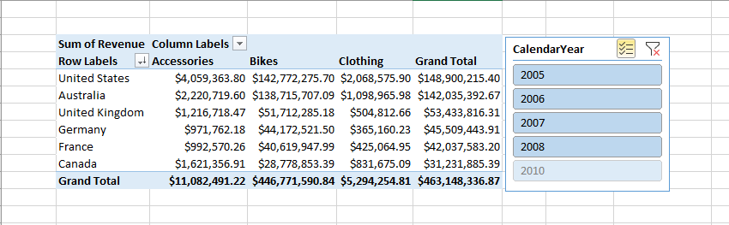

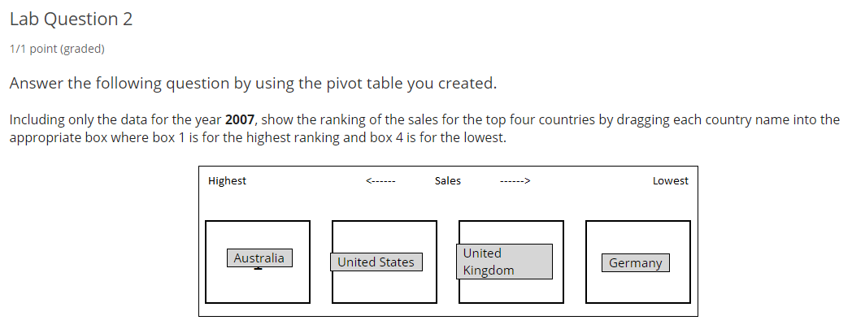

As per below sorted and filtered table for 2007 data,

Ans will be: Australia => US => UK => Germany

